Touchless Touchscreen Technology: A Literature Review

Udit Gupta^{1st} , Sofiya Chaudhary^{2nd}
3th year Students , Bachelor of technology in computer science (CS), Teerthanker Mahaveer University, Moradabad, Uttar Pradesh

Abstract : The advancements in touchless touchscreen technology have opened up new possibilities for human-computer interactions. This research paper explores the various aspects of touchless touchscreens, including their working principles, applications, advantages, limitations, and challenges. A comprehensive analysis of existing research papers and studies provides insights into the state-of-the-art technology and its potential impact on various industries. The paper also discusses the comparison between touchless touchscreens and traditional touchscreens, highlighting their unique features and use cases. Furthermore, it presents an overview of the current advancements, challenges, and future directions in touchless touchscreen technology. The research paper aims to contribute to the existing knowledge base and provide a comprehensive understanding of the potential of touchless touchscreens.

1.INTRODUCTION

Touchless touchscreen technology has revolutionized human-computer interaction by allowing users to interact with electronic displays without physical touch. Traditional touchscreen devices required direct contact with the screen, but with touchless touchscreens, users can now engage with digital content through gesture recognition and proximity sensors. This groundbreaking technology has significant implications for various industries and sectors, ranging from healthcare to retail, automotive, gaming, and more.
The objective of this research paper is to provide a comprehensive understanding of touchless touchscreen technology, its applications, advantages, limitations, and future prospects. Through an extensive literature review and analysis of research papers, this paper aims to contribute to the existing body of knowledge and shed light on the potential impact of touchless touchscreens.
To achieve these objectives, a systematic approach has been followed. A thorough examination of relevant literature, research papers, industry reports, and academic publications has been conducted. This comprehensive review helps in gathering insights into the working principles, sensing technologies, and gesture recognition algorithms utilized in touchless touchscreens. Moreover, empirical studies and case examples have been examined to provide practical insights and real-world applications.
The findings from this research paper will aid in understanding the advantages and limitations of touchless touchscreen technology. Furthermore, it will explore the comparative analysis between touchless touchscreens and traditional touchscreens, highlighting the unique benefits and challenges of each. This research paper also delves into the potential future developments and emerging trends in touchless touchscreen technology, such as advancements in sensing technologies, integration with artificial intelligence, haptic feedback, and multi-modal interactions.

2. HISTORY

The history of touchless touchscreen technology can be traced back to the early development of touchscreens themselves. The concept of touch-sensitive screens emerged in the 1960s, with early experiments conducted by researchers such as E.A. Johnson and Frank Beck at the Royal Radar Establishment in the United Kingdom. These early touchscreens were resistive in nature, relying on the pressure applied by physical touch to detect user inputs.
Over the years, touchscreens evolved and became more prevalent in various industries. In the 1980s, the introduction of capacitive touchscreens, which detect changes in electrical properties when touched, revolutionized the field. Capacitive touchscreens offered improved sensitivity and reliability compared to resistive touchscreens, leading to their widespread adoption in devices such as point-of-sale systems, ATMs, and personal digital assistants.
The development of touchless touchscreen technology can be seen as a natural progression from traditional touchscreens. The desire for more hygienic and intuitive user interfaces, coupled with advancements in sensing technologies, paved the way for touchless touchscreens. One of the key milestones in touchless technology was the introduction of optical touchscreens in the early 2000s.
Optical touchscreens utilized cameras or optical sensors placed around the edges of the screen to detect changes in light patterns caused by user interactions. This allowed for touchless gesture recognition, enabling users to control and interact with the display without physical touch. Optical touchscreens found applications in gaming consoles, interactive kiosks, and public displays.
In recent years, with the rise of depth-sensing technologies such as infrared sensors and depth cameras, touchless touchscreens have become even more sophisticated. These technologies enable precise tracking of hand movements and gestures, allowing for more complex and intuitive interactions. Additionally, advancements in machine learning and computer vision algorithms have enhanced the accuracy and robustness of gesture recognition in touchless touchscreens.
The adoption of touchless touchscreen technology has been driven by various factors. The ongoing COVID-19 pandemic has highlighted the need for hygienic interfaces that minimize the spread of germs through physical touch. The healthcare industry, in particular, has embraced touchless touchscreens to improve infection control in medical facilities.
Furthermore, touchless touchscreens offer enhanced accessibility for individuals with physical disabilities, as they eliminate the need for precise fine motor control or the ability to exert pressure on a screen. This inclusivity has made touchless touchscreens an attractive option in healthcare, education, and public spaces.

3.1 WORKING OF TOUCHLESS TOUCHSCREEN
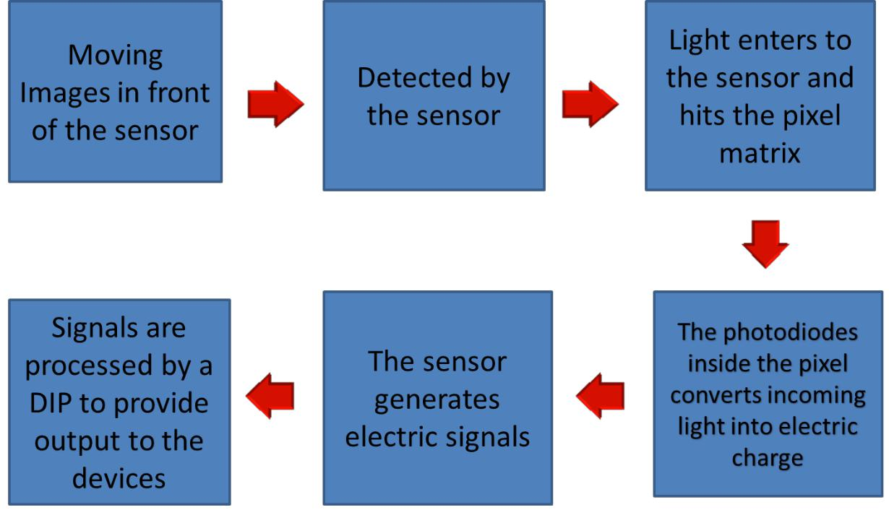

The working of touchless touchscreens involves a combination of sensing technologies, gesture recognition algorithms, and user interaction. These touchscreens rely on advanced sensors, such as optical sensors, infrared sensors, or depth cameras, to capture and interpret user inputs without the need for physical touch.
When a user approaches a touchless touchscreen, the sensors detect their presence or hand movements in front of the display. The sensors capture data about the user's hand position, distance, and motion. This information is then processed by sophisticated gesture recognition algorithms, which analyze the data to identify specific gestures or movements.
The gesture recognition algorithms interpret the captured data and translate it into meaningful commands or actions. For example, a simple swipe gesture might be interpreted as a scroll action on a document or a menu selection. More complex gestures, such as pinching or spreading fingers, can be recognized for zooming in or out on a digital map or image. The accuracy and responsiveness of the gesture recognition system play a vital role in ensuring a seamless and intuitive user experience.
To achieve precise and reliable touchless interaction, the touchless touchscreen technology takes into account factors such as hand speed, direction, and the shape of gestures. It utilizes machine learning techniques to continuously improve the recognition accuracy and adapt to individual user preferences and variations in hand movements.
Additionally, touchless touchscreens may incorporate feedback mechanisms to provide visual or audio cues to users, confirming the successful recognition of their gestures or actions. This feedback helps users understand and engage with the touchless interface more effectively.
The working of touchless touchscreens is not limited to hand gestures alone. It can also extend to other forms of touchless interaction, such as proximity-based actions. For instance, when a user's hand approaches a specific area of the screen, the system may trigger a hover effect or display contextual information without physical contact.
It is important to note that the working of touchless touchscreens can vary depending on the specific technology and implementation. Different sensing technologies, such as optical or depth-based systems, may have their unique working principles and requirements. However, the underlying concept remains the same - capturing user inputs through non-contact gestures and translating them into meaningful interactions with the digital display.
Overall, touchless touchscreens offer a novel and intuitive way for users to interact with digital interfaces without the need for physical touch. By leveraging advanced sensing technologies and gesture recognition algorithms, touchless touchscreens open up new possibilities for hygienic, accessible, and engaging user experiences in various applications and industries.

4.2 Gesture Based Graphical User Interface (Gbui)
Leap motion controller is used to turn hand movements into computer commands. Initial research was conducted to determine how the controller worked and to understand basic interaction. The controller is used for evaluating sign language comprehension. The finger spelling alphabet was chosen for the relative simplicity of individual signs and the alphabet's diverse range of movements. These experiments concentrate on assessing the controller's capabilities and ability to identify hand movements. Various movements or actions have a particular meaning.

4.3 APPLICATIONS
The applications of Touchless Screen Technology are :
• Touchless Monitor
• Touch Wall
• Touchless UI
• Touchless SDK

